**A**

## Project Report

### On

**Attendance Management System Using Face Detection**

***Submitted in partial fulfillment for the award of degree of* Bachelor of Technology**

**In**

**Computer Science & Engineering**



## Submitted by: Project Guide:

#### Atul Sisodiya

#### 18EJCCS030 B. UmaMaheswari

(Assistant Professor)

**Department of Computer Science & Engineering** Jaipur Engineering College & Research Centre Jaipur, Rajasthan

2021-22

# CANDIDATE’S DECLARATION

I, hereby declare that the work presented in this project entitled “**Attendance Management System Using Face Detection”** in the partial fulfillment of the requirements for the award of the Degree of Bachelor of Technology in Computer Science & Engineering at Jaipur Engineering College and Research Centre, Jaipur is an authentic work of my own.

I have not submitted the matter embodied in this project work anywhere for the award of degree of Bachelor of Technology in Computer Science & Engineering.

**Name: Atul Sisodiya**

**Roll No. 18EJCCS030**

**Date:**

**Place: Jaipur**

# BONAFIDE CERTIFICATE

This is to certify that the project entitled **" Attendance Management System Using Face Detection "** is the bonafide work carried out by **Atul Sisodiya** student of B.Tech.in Computer Science & Engineering at Jaipur Engineering College and Research Centre, during the year 2021-22 in partial fulfillment of the requirements for the award of the Degree of Bachelor of Technology in Computer Science & Engineering and the project has not formed the basis for the award previously of any degree, diploma, fellowship or any other similar title.

**Name of Guide: B. Uma Maheswari Designation: Assistant Professor Place: Jaipur**

**Date:**

# VISION OF CSE DEPARTMENT

To become renowned Centre of excellence in computer science and engineering and make competent engineers & professionals with high ethical values prepared for lifelong learning.

# MISSION OF CSE DEPARTMENT

1. To impart outcome based education for emerging technologies in the field of computer science and engineering.
2. To provide opportunities for interaction between academia and industry.
3. To provide platform for lifelong learning by accepting the change in technologies.
4. To develop aptitude of fulfilling social responsibilities.

## PROGRAM OUTCOMES (POs)

1. **Engineering knowledge:** Apply the knowledge of mathematics, science, engineering fundamentals, and an engineering specialization to the solution of complex engineering problems.
2. **Problem analysis**: Identify, formulate, research literature, and analyze complex engineering problems reaching substantiated conclusions using first principles of mathematics, natural sciences, and engineering sciences.
3. **Design/development of solutions**: Design solutions for complex engineering problems and design system components or processes that meet the specified needs with appropriate consideration for the public health and safety, and the cultural, societal, and environmental considerations.
4. **Conduct investigations of complex problems**: Use research-based knowledge and research methods including design of experiments, analysis and interpretation of data, and synthesis of the information to provide valid conclusions.
5. **Modern tool usage**: Create, select, and apply appropriate techniques, resources, and modern engineering and IT tools including prediction and modeling to complex engineering activities with an understanding of the limitations.
6. **The engineer and society**: Apply reasoning informed by the contextual knowledge to assess societal, health, safety, legal and cultural issues and the consequent responsibilities relevant to the professional engineering practice.
7. **Environment and sustainability**: Understand the impact of the professional engineering solutions in societal and environmental contexts, and demonstrate the knowledge of, and need for sustainable development.
8. **Ethics**: Apply ethical principles and commit to professional ethics and responsibilities and norms of the engineering practice.
9. **Individual and team work**: Function effectively as an individual, and as a member or leader in diverse teams, and in multidisciplinary settings.
10. **Communication**: Communicate effectively on complex engineering activities with the engineering community and with society at large, such as, being able to comprehend and write effective reports and design documentation, make effective presentations, and give and receive clear instructions.
11. **Project management and finance**: Demonstrate knowledge and understanding of the engineering and management principles and apply these to one’s own work, as a member and leader in a team, to manage projects and in multidisciplinary environment.
12. **Life-long learning**: Recognize the need for, and have the preparation and ability to engage in independent and life-long learning in the broadest context of technological change.

## PROGRAM EDUCATIONAL OBJECTIVES (PEOs)

The PEOs of the B.Tech (CSE) program are:

**PEO1**: To provide students with the fundamentals of Engineering Sciences with more emphasis in computer science and engineering by way of analyzing and exploiting engineering challenges.

**PEO2:** To train students with good scientific and engineering knowledge so as to comprehend, analyze, design, and create novel products and solutions for the real life problems.

**PEO3**: To inculcate professional and ethical attitude, effective communication skills, teamwork skills, multidisciplinary approach, entrepreneurial thinking and an ability to relate engineering issues with social issues.

**PEO4:** To provide students with an academic environment aware of excellence, leadership, written ethical codes and guidelines, and the self-motivated life-long learning needed for a successful professional career.

**PEO5**: To prepare students to excel in Industry and Higher education by educating Students along with High moral values and Knowledge.

## PROGRAM SPECIFIC OUTCOMES (PSOs)

**PSO1:** Ability to interpret and analyze network specific and cyber security issues, automation in real word environment.

**PSO2:** Ability to Design and Develop Mobile and Web-based applications under realistic constraints.

## COURSE OUTCOMES (COs)

On completion of project Graduates will be able to-

* CO1: Gather, organize, summarize and interpret technical literature with the purpose of formulating a project proposal.
* CO2: Design/Develop the solution using latest technologies and communicate via modern tools.
* CO3 Understand and develop the professional, social ethics, and team management principles.

**MAPPING: CO’s & PO’s**

**Subject Code**

**L**

**/ T**

**/**

**P**

**CO**

**P P P P P P P P P P P P**

**O O O O O O O O O O O O 1 2 3 4 5 6 7 8 9 1 1 1**

**0 1 2**

Graduates will be able to: gather, organize, summarize and interpret technical literature with the purpose of formulating a project proposal.

3 3

3 2 2 2 1 2 1 2 2 3

P

**Project** 8CS7-50

P

Graduates will be able to: Design/Develop the solution using latest technologies and communicate via modern

tools.

3 3 3 2 2 2 1 2 2 2 2 3

P

Graduates will be able to: Understand and develop the professional, social ethics, and

team management principles.

3 3 3 2 2 2 1 2 2 2 2 3

# ACKNOWLEDGEMENT

I wish to express our deep sense of gratitude to our Project Guide Mr. Amit Mithal sir, Jaipur Engineering College and Research Centre, Jaipur for guiding us from the inception till the completion of the project. We sincerely acknowledge him for giving his valuable guidance, support for literature survey, critical reviews and comments for our Project.

I would like to first of all express our thanks to **Mr. Arpit Agrawal** Director of JECRC, for providing us such a great infrastructure and environment for our overall development.

I express sincere thanks to **Dr. V. K. Chandna**, Principal of JECRC, for his kind cooperation and extendible support towards the completion of our project.

Words are inadequate in offering our thanks to **Dr. Sanjay Gaur,** HOD of CSE department, for consistent encouragement and support for shaping our project in the presentable form.

I also like to express our thanks to all supporting CSE faculty members who have been a constant source of encouragement for successful completion of the project.

Also our warm thanks to **Jaipur Engineering College and Research Centre**, who provided us this opportunity to carryout, this prestigious Project and enhance our learning in various technical fields.

**Student Name: Atul Sisodiya**

**Univ. Roll No.: 18EJCCS030**

## Abstract

This project is about the biometric attendance management. The automatic attendance management will replace the manual method, which takes a lot of time consuming and difficult to maintain. There are many biometric processes, in that face recognition is the best method. In this report we are going to describe the attendance without human interference. In this method the camera is fixed in the classroom and it will capture the image, the faces are detected and then it is recognized with the database and finally the attendance is marked. If the attendance is marked it is stored in the database.

# TABLE OF CONTENTS

**Introduction 1**

**Requirement Analysis 3**

**Technologies Uses 4**

**Design Methodology 9**

**Data Flow Diagram 11**

**Implementation 14**

**How Project Works 17**

**Algorithm 19**

**Project 20**

**Limitation 36**

**Future Scope 37**

**Examples of Sentiment Analysis in action--------------------------------------------------------37**

**Conclusion 39**

**References 40**

**List of Figures**

**Figure 1 1**

**Figure 2 4**

**Figure 3 5**

**Figure 4 6**

**Figure 5 7**

**Figure 6 9**

**Figure 7 9**

**Figure 8 10**

**Figure 9 15**

**Figure 10 16**

**Figure 11 17**

**Figure 12-------------------------------------------------------------------------------------------------19**

**Figure 13 25**

**Figure 14 36**

### INTRODUCTION

The At present facial recognition and image processing isa very interesting topic that has only had its surface scratched, facial recognition is quickly surpassing other forms of biometrics (Fingerprints, RFID etc) as facial recognition systems use a set of features distinct to one person. This proposed project can be applied to create an attendance system using facial recognition as the traditional method i.e., pen and paper is not only time consuming and burdensome it is also prone to proxies and manipulation, our aim in developing this project is to make the attendance system eﬃcient, stop methods and means of proxies and to save time that would otherwise be lost int he lecture.The idea for this project came to us in class as we saw the amount of time that has to be skipped for attendance and the nonchalance of students who had already marked t heir attendance which leads to the method being delayed further, we then decided that this would be a good and interesting ﬁeld to delve into for our Project as the ﬁeld of Image processing, recognition etc.

##### Purpose

The idea of this product is to provide an Attendance management system using face detection with help of python programming language. Machine learning Model is trained to capture the image and mark the attendance to the database as an added feature we can also check the emotions of the subject. It is very fast and smart method to accurately mark the attendance at various instititutions.

In this project, we systematically analyze a deep neural network and openCV. With an image as the input, the method can output a meaningful sentence describing the content in the image. We analyze three components of the method: convolutional neural network (CNN), recurrent neural network (RNN) and sentence generation. The main focus of the project is to help persons with visual disabilities. It provides them new virtual vision through audio. It helps them identify and develop a sense for objects in their surroundings.

A person can interact and communicate with the product which works as an alternative for their eyes. The enhanced technology like Machine Learning, NLP, CNN etc. ensures the accuracy and correctness of the product.

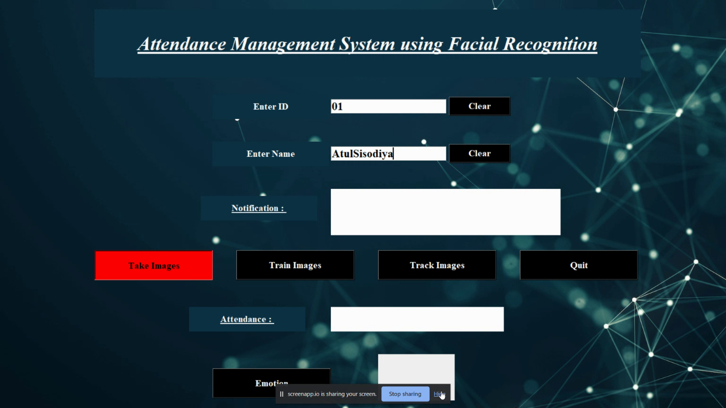

**Fig: UI of Project Developed**

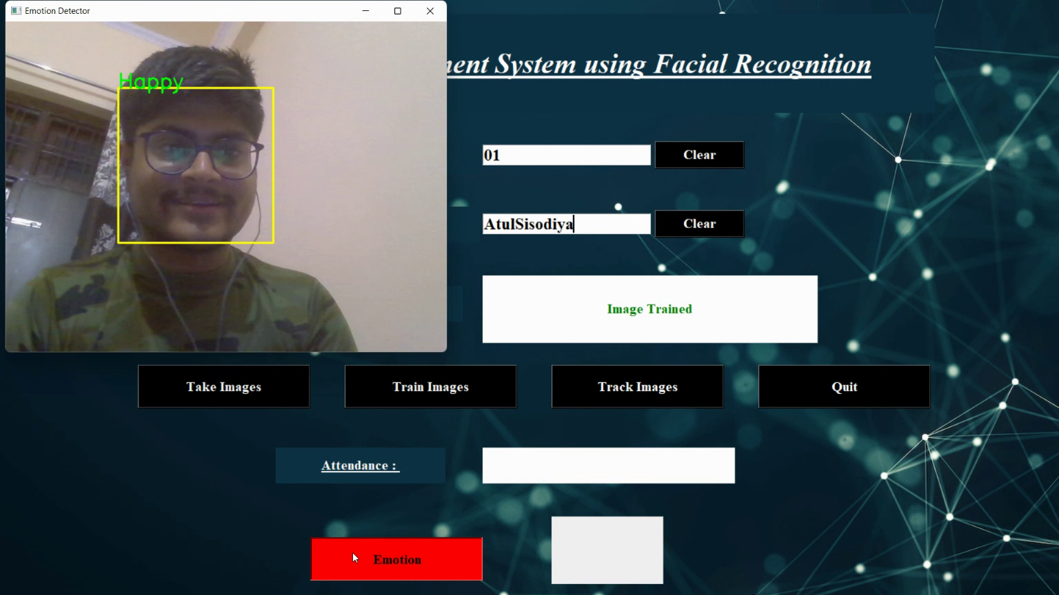

**Fig : Added Feature of Emotion Detection**

### REQUIREMENT ANALYSIS

The main purpose for preparing this document is to give a general insight into the analysis and requirements of the existing system or situation and for determining the operating characteristics of the system. This Document plays a vital role in the development life cycle (SDLC) and it describes the complete requirement of the system. It is meant for use by the developers and will be the basic during testing phase. Any changes made to the requirements in the future will have to go through formal change approval process.

##### Hardware Requirement

Hardware Specification:

* + - Processor: Intel I5 (or above)
    - RAM: 12 GB (or above)
    - Hard disk: 500 GB (or above)

##### Software Requirement

* Windows OS
* Jupyter Notebook / Google Colab

### Technologies Used:

##### Front End

* Python:

**Python** is a [high-level](https://en.wikipedia.org/wiki/High-level_programming_language), [interpreted,](https://en.wikipedia.org/wiki/Interpreter_(computing)) [general-purpose programming language](https://en.wikipedia.org/wiki/General-purpose_programming_language). Its design philosophy emphasizes [code readability](https://en.wikipedia.org/wiki/Code_readability) with the use of [significant indentation](https://en.wikipedia.org/wiki/Off-side_rule). Python is [dynamically-typed](https://en.wikipedia.org/wiki/Type_system#DYNAMIC) and [garbage-collected](https://en.wikipedia.org/wiki/Garbage_collection_(computer_science)). It supports multiple [programming paradigms](https://en.wikipedia.org/wiki/Programming_paradigm), including [structured](https://en.wikipedia.org/wiki/Structured_programming) (particularly [procedural](https://en.wikipedia.org/wiki/Procedural_programming)), [object-oriented](https://en.wikipedia.org/wiki/Object-oriented_programming) and [functional programming](https://en.wikipedia.org/wiki/Functional_programming). It is often described as a "batteries included" language due to its comprehensive [standard library.](https://en.wikipedia.org/wiki/Standard_library) It was designed by Guido Van Rossum in 1980.

Python supports modules and packages, which encourages program modularity and code reuse. The Python interpreter and the extensive standard library are available in source or binary form without charge for all major platforms, and can be freely distributed.

Often, programmers fall in love with Python because of the increased productivity it provides. Since there is no compilation step, the edit-test-debug cycle is incredibly fast. Debugging Python programs is easy: a bug or bad input will never cause a segmentation fault. Instead, when the interpreter discovers an error, it raises an exception. When the program doesn't catch the exception, the interpreter prints a stack trace.

A source level debugger allows inspection of local and global variables, evaluation of arbitrary expressions, setting breakpoints, stepping through the code a line at a time, and so on. The debugger is written in Python itself, testifying to Python's introspective power. On the other hand, often the quickest way to debug a program is to add a few print statements to the source: the fast edit-test-debug cycle makes this simple approach very effective.

Python Syntax compared to other programming languages

* Python was designed for readability, and has some similarities to the English language with influence from mathematics.
* Python uses new lines to complete a command, as opposed to other programming languages which often use semicolons or parentheses.
* Python relies on indentation, using whitespace, to define scope; such as the scope of loops, functions and classes. Other programming languages often use curly-brackets for this purpose.

##### Back End

* Python:

**Python** is a [high-level](https://en.wikipedia.org/wiki/High-level_programming_language), [interpreted,](https://en.wikipedia.org/wiki/Interpreter_(computing)) [general-purpose programming language](https://en.wikipedia.org/wiki/General-purpose_programming_language). Its design philosophy emphasizes [code readability](https://en.wikipedia.org/wiki/Code_readability) with the use of [significant indentation](https://en.wikipedia.org/wiki/Off-side_rule). Python is [dynamically-typed](https://en.wikipedia.org/wiki/Type_system#DYNAMIC) and [garbage-collected](https://en.wikipedia.org/wiki/Garbage_collection_(computer_science)). It supports multiple [programming paradigms](https://en.wikipedia.org/wiki/Programming_paradigm), including [structured](https://en.wikipedia.org/wiki/Structured_programming) (particularly [procedural](https://en.wikipedia.org/wiki/Procedural_programming)), [object-oriented](https://en.wikipedia.org/wiki/Object-oriented_programming) and [functional programming](https://en.wikipedia.org/wiki/Functional_programming). It is often described as a "batteries included" language due to its comprehensive [standard library.](https://en.wikipedia.org/wiki/Standard_library) It was designed by Guido Van Rossum in 1980.

* Machine learning:

Machine learning (ML) is a type of artificial intelligence (AI) that allows software applications to become more accurate at predicting outcomes without being explicitly programmed to do so. Machine learning algorithms use historical data as input to predict new output values.

* Deep learning:

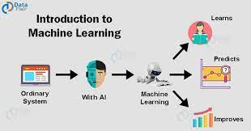

Deep learning is a machine learning technique that teaches computers to do what comes naturally to humans: learn by example. Deep learning is a key technology behind driverless cars, enabling them to recognize a stop sign, or to distinguish a pedestrian from a lamppost.

Two important neural networks are used. They are:

##### CNN:

Within Deep Learning, a Convolutional Neural Network or CNN is a type of artificial neural network, which is widely used for image/object recognition and classification. Deep Learning thus recognizes objects in an image by using a CNN. Some neurons fires when exposed to **vertices** edges and some when shown **horizontal** or **diagonal edges**. CNN utilizes spatial correlations which exist with the input data. Each concurrent layer of the neural network connects some input neurons. This region is called a local receptive field. The local receptive field focuses on hidden neurons. The hidden neuron processes the input data inside the mentioned field, not realizing the changes outside the specific boundary.

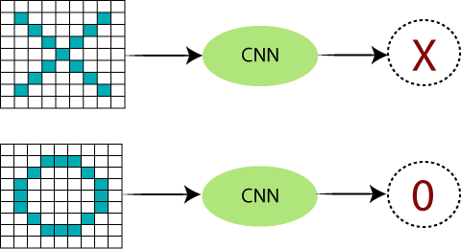

Fig: 2 CNN

There are certain **trickier** cases where **X** can represent in these four forms as well as the right side, so these are nothing but the effects of the deformed images. Here, there are multiple presentations of **X** and **O's**. This makes it tricky for the computer to recognize. But the goal is that if the **input signal** looks like **previous** images, it has seen before, the **"image" reference** signal will be convolved with, the input signal. The resulting **output** signal is then passed on to the **next layer**.

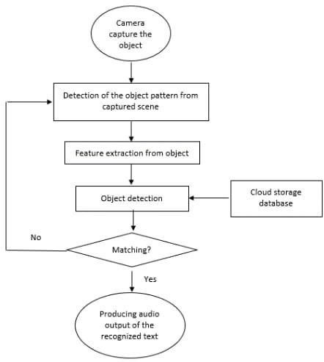

Fig: 3 CNN Flow Diagram

##### RNN:

Recurrent neural networks recognize data's sequential characteristics and use patterns to predict the next likely scenario. RNNs are used in deep learning and in the development of models that simulate neuron activity in the human brain. RNNs are called recurrent because they perform the same task for every element of a sequence, with the output being depended on the previous computations. Another way to think about RNNs is that they have a “memory” which captures information about what has been calculated so far.

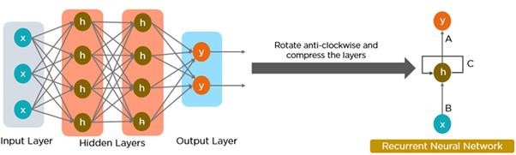

Fig: 4 RNN

RNN converts the independent activations into dependent activations by providing the same weights and biases to all the layers, thus reducing the complexity of increasing parameters and memorizing each previous outputs by giving each output as input to the next hidden layer.

* OpenCV:

OpenCV is a great tool for image processing and performing computer vision tasks. It is an open- source library that can be used to perform tasks like face detection, objection tracking, landmark detection, and much more. It supports multiple languages including python, java C++.

OpenCV-**Python is a library of Python** bindings designed to solve computer vision problems. Python is a general-purpose programming language started by Guido van Rossum that became very popular very quickly, mainly because of its simplicity and code readability.

**Haar cascade:** Basically, the Haar cascade technique is an approach based on machine learning where we use a lot of positive and negative images to train the classifier to classify between the images. Haar cascade classifiers are considered as the effective way to do object detection with the OpenCV library. Now, let's understand the concept of positive and negative images that we have discussed earlier:

* **Positive images:** These are the images that contain the objects which we want to be identified from the classifier.
* **Negative Images:** These are the images that do not contain any object that we want to be detected by the classifier, and these can be images of everything else.
* NTLK:

NTLK (Natural Language Toolkit ) is **a toolkit build for working with NLP in Python**. It provides us various text processing libraries with a lot of test datasets. A variety of tasks can be performed using NLTK such as tokenizing, parse tree visualization, etc.

* Regular Expression:

A Regular Expression (or Regex) is a pattern (or filter) that describes a set of strings that matches the pattern. In other words, a regex accepts a certain set of strings and rejects the rest.

### Design Methodology:

The systems development life-cycle concept applies to a range of hardware and software configurations, as a system can be composed of hardware only, software only, or a combination of both. If the SDLC concept is adhere to, the programmer will derive good software that is error free that will satisfied all the needs in a good condition. The phases are as follows:

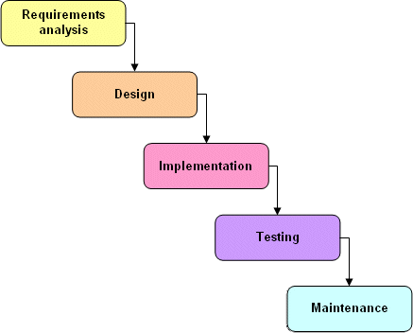

Fig: 5

**Requirements Phase:** Automation needs of the business functions are collected and quantified. The requirements include business rules that govern the work of the user, definition of specific business functions or processes, and levels of security needed to protect the business’ information.

**Analysis phase:** In the analysis phase the requirements gathered in the requirements phase, are used to create report definitions and layouts, screen definitions and layouts, data element definitions, workflow diagrams, and security matrices.

**Design phase:** In the design phase the logical model developed in the analysis phase, is used to develop a “physical” model of the application. The physical model contains business object logic, database schemas identifying relationships, web object design and layout, report calculations and processing, and the security object definition.

**Coding/development phase:** In the coding/development phase the individual objects or components of the application are coded from the physical model. Once the system objects have been developed, they are gathered and connected together (integrated) to create a working application. The integrated application is placed on a staging server for testing.

**Testing phase:** This encompasses three testing stages; component testing, requirements testing, and acceptance testing. In all testing stages, defects are identified and returned to the development/coding phase for correction.

**Maintenance phase:** In the maintenance phase the deployed application is maintained through scheduled backups. Any changes to the application are presented to the programmer. If a change or enhancement has been approved by the programmer, it is presented to the organization and the software development life cycle begins again.

### Data Flow Diagrams :

A data flow diagram is graphical tool used to describe and analyze movement of data through a system. These are the central tool and the basis from which the other components are developed. The transformation of data from input to output, through processed, may be described logically and independently of physical components associated with the system. These are known as the logical data flow diagrams.

The physical data flow diagrams show the actual implements and movement of data between people, departments and workstations. A full description of a system actually consists of a set of data flow diagrams.

Using two familiar notations Yourdon, Gane and Sarson notation develops the data flow diagrams. Each component in a DFD is labeled with a descriptive name. Process is further identified with a number that will be used for identification purpose. The development of DFD’S is done in several levels.

Data flowcharts can range from simple, even hand-drawn process overviews, to in-depth, multi-level DFDs that dig progressively deeper into how the data is handled. They can be used to analyze an existing system or model a new one.

Like all the best diagrams and charts, a DFD can often visually “say” things that would be hard to explain in words, and they work for both technical and nontechnical audiences, from developer to CEO. That’s why DFDs remain so popular after all these years. While they work well for data flow software and systems, they are less applicable nowadays to visualizing interactive, real-time or database-oriented software or systems.

Three common systems of symbols are named after their creators:

* Yourdon and Coad
* Yourdon and DeMarco
* Gane and Sarson

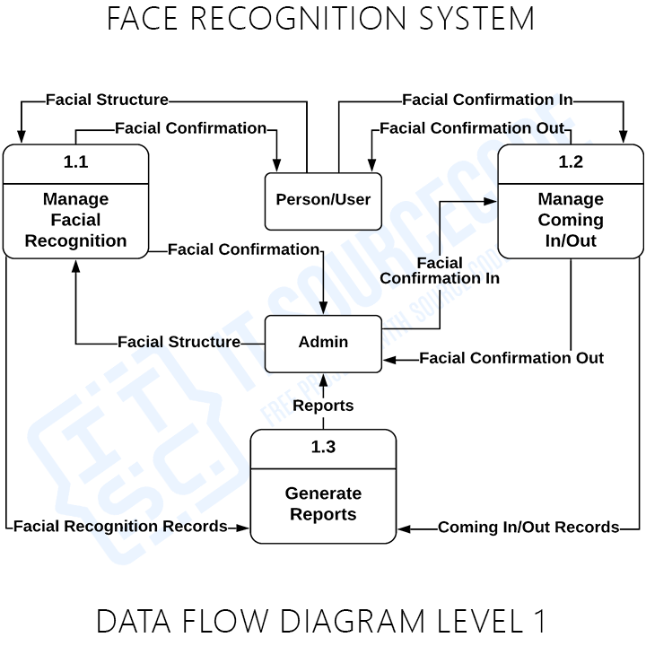

Fig: 7 DFD Level – 1

The lop-level diagram is often called context diagram. It consists a single process bit, which plays vital role in studying the current system. The process in the context level diagram is exploded into other process at the first level DFD

##### Use case Diagram

A use case diagram at its simplest is a representation of a user's interaction with the system that shows the relationship between the user and the different use cases in which the user is involved. A use case diagram can identify the different types of users of a system and the different use cases and will often be accompanied by other types of diagrams as well.

There are three basic elements that make up a use case:

* + - Actors: Actors are the type of users that interact with the system.
    - System: Use cases capture functional requirements that specify the intended behavior of the system.
    - Goals: Use cases are typically initiated by users to fulfill goals describing the activities and variants involved in attaining the goal.

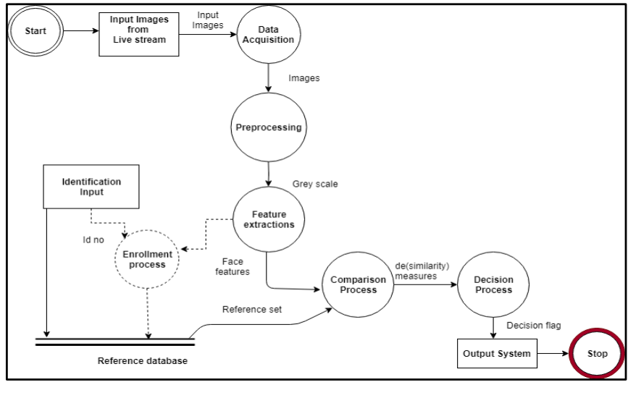

Fig: 8 Data flow throughout

### IMPLEMENTATION

**6.1 Primary database creation and training**

The original database containing the images of the students is created by taking a live real time video of the students, and splitting the video into thirty frames, con-verting them to gray scale and storing only the faces of the students as images, then we will be training the respective images using the LBPH algorithm all the while storing their respective histogram value’s and then comparing the stored and trained images against the captured images to mark the attendance. The software used for splitting the video into frames is **Open-CV.**

**6.2 Image Capturing Phase**

In this phase the professor will capture a real time video of the class room or lecture hall by means of their own mobile device and making use of the Droid Cam application which links the system that is running on your laptop to your mobile device and lets you use your mobile cam-era to capture the students present in the class room, the system can be accessed by the professors by accessing the laptop where all the data is stored.

**6.3 Image Detection Phase**

In this second phase once the video has begun capturing, simultaneously the Haar Cascade algorithm is applied to the video to get individual faces of the students and obtaining the distinct features of their face(eyes, nose, ears and lips) by making use of line features and edge features, the Haar cascade algorithm basically works by giving us the parts of the face that are needed most for detection i.e. the ROI (Region of Interest) and processing and cropping out other regions of the face that do not play a role in the image processing and matching part. Once the faces are detected they are extracted and stored.

**6.4 Image Matching Phase**

In this third and most crucial phase of recognizing the student, that is comparing captured image against the stored images in the database, this method is done by making use of the LBPH algorithm (Local Binary Pattern Histogram), each image stored in the database has it’s histogram value calculated and is cross checked against the calculated Histogram value of the images extracted from the captured video feed. The name of the student appears above and the number indicates the conﬁdence. Note: Lower the conﬁdence number higher is the accuracy. As we can see from Fig, the system not only detects just one face of a single student, but of multiple students or faces. As the system works for three faces at once by law of induction we can say that it will work for at least more than 15 faces at a single time



**Fig: Input Data**

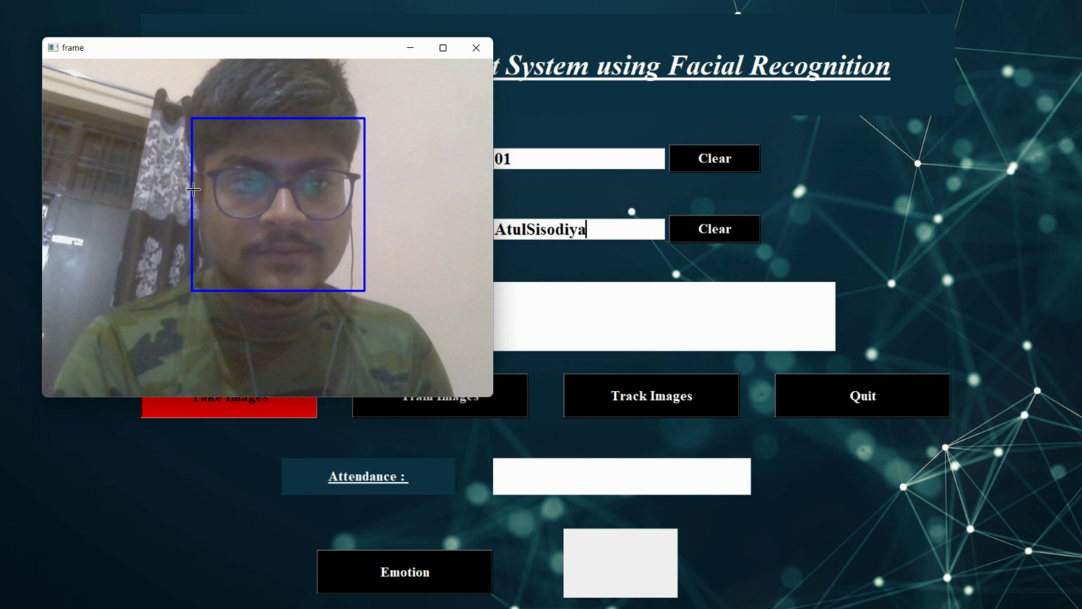

**Fig: Capturing and Registering Image**

**6.5 Attendance Marking Phase**

In this phase the attendance is marked, if the uploaded im-age matches the image stored in the database, then the at-tendance is marked present for that lecture and saved, but if any student goes unrecognized then that particular image is stored in the secondary database and an alert is generated for the admin.

**6.6 Proposed Architecture**

The architecture for the proposed system has been designed to keep it pretty straightforward and easy to understand. The steps that have to be undertaken to reach the ﬁnal end step of the system which is making sure the attendance of the student is updated correctly and timely. The system can easily be accessed by anyone, where attendance of the students can easily be checked and maintained by the faculty as when required. The Droid-Cam ap will allow easy use for capturing live video feeds of the class and simultaneously perform recognition for the students. OpenCV-Python will be used to access the Haar Cascade and LBPH algorithms and their libraries that are required for training, recognition and matching of the captured im-ages against the stored images available in the previously acquired data sets. Algorithms being used:

### How Project works :

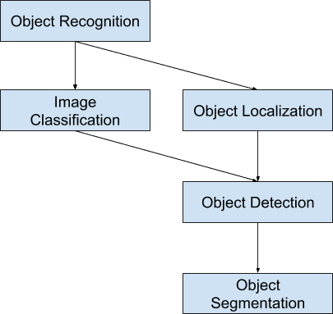

Fig : 9 Flow chart of project progress

* **Image Classification**: Predict the type or class of an object in an image.
* Input: An image with a single object, such as a photograph.
* Output: A class label (e.g., one or more integers that are mapped to class labels).
* **Object Localization**: Locate the presence of objects in an image and indicate their location with a bounding box.
* Input: An image with one or more objects, such as a photograph.
* Output: One or more bounding boxes (e.g., defined by a point, width, and height).
* **Object Detection**: Locate the presence of objects with a bounding box and types or classes of the located objects in an image.
* Input: An image with one or more objects, such as a photograph.
* Output: One or more bounding boxes (e.g., defined by a point, width, and height), and a class label for each bounding box.

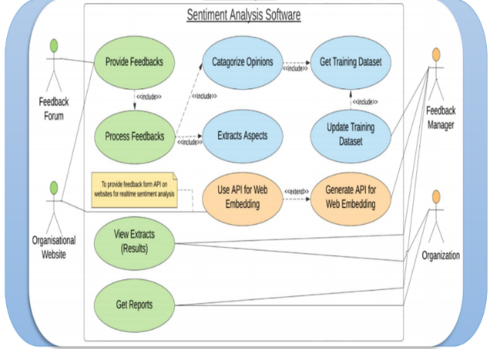

Fig: 10 Use Case Diagram

### Algorithm:

### 

### Fig: 11 Logistic Regression

Accuracy achieved - 93% (approx.)

Logistic regression is a supervised learning classification algorithm used to predict the probability of a target variable. The nature of target or dependent variable is dichotomous, which means there would be only two possible classes.

In simple words, the dependent variable is binary in nature having data coded as either 1 (stands for success/yes) or 0 (stands for failure/no).

1. **Project**

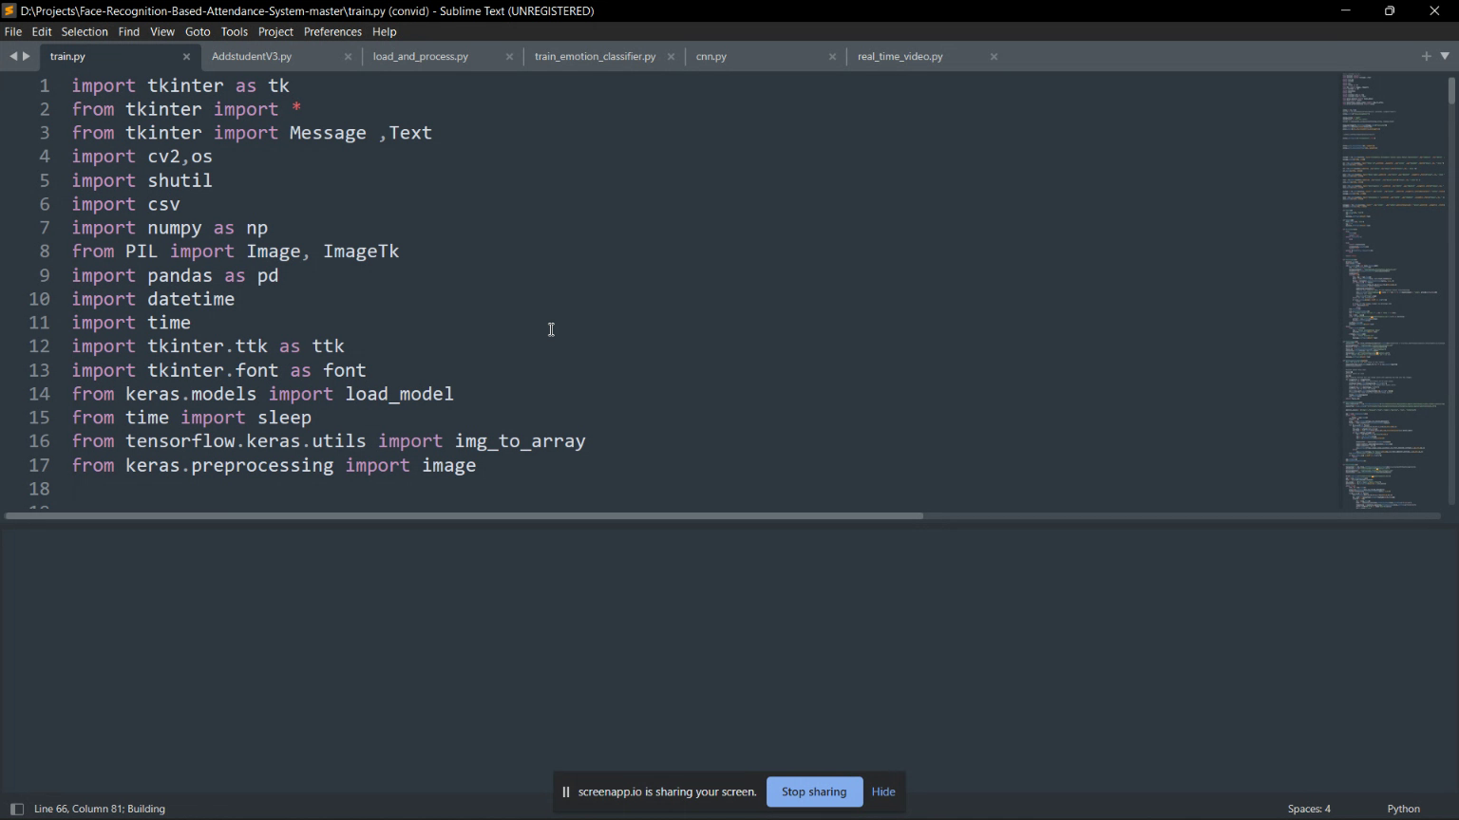

Fig: 12 Code Snaps

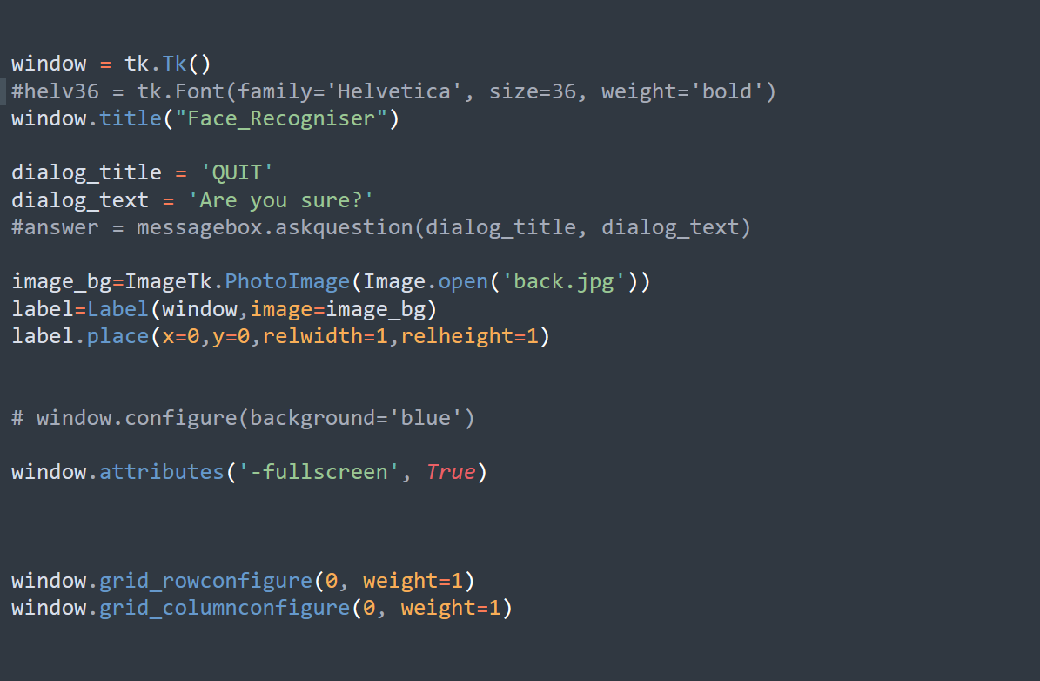

Fig. Tkinter window start

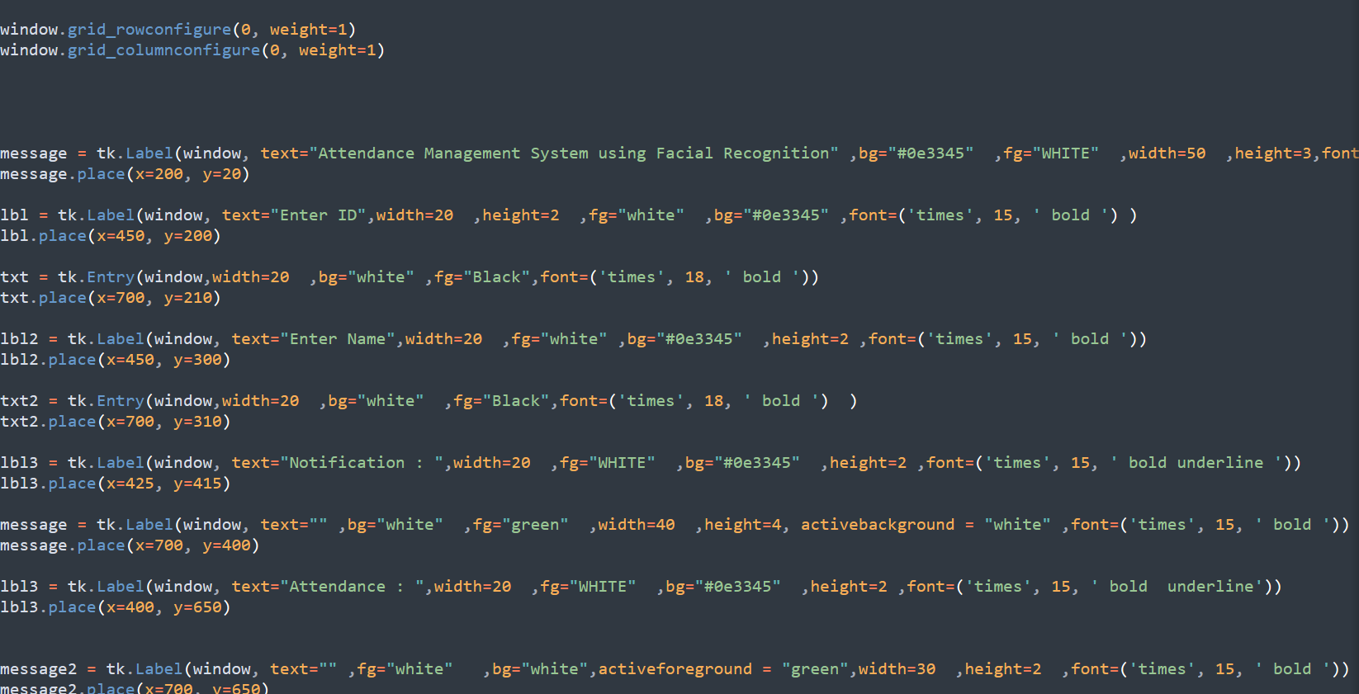

Fig. Design Tkinter Panel

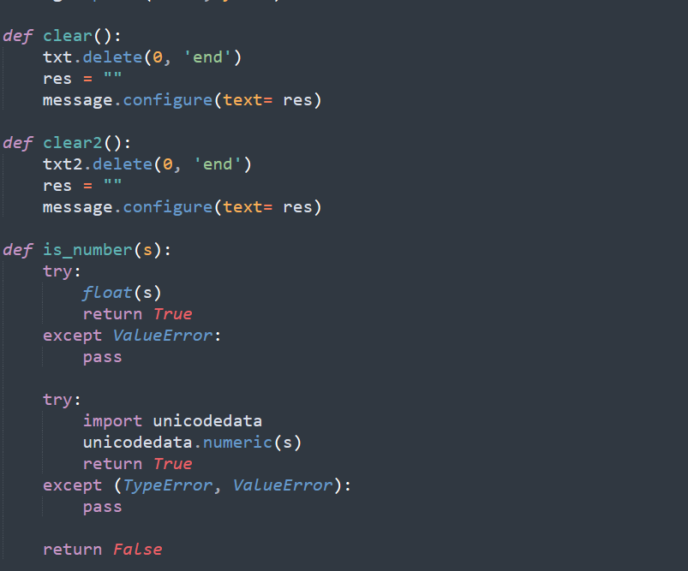

Fig. Defining Button Finctions

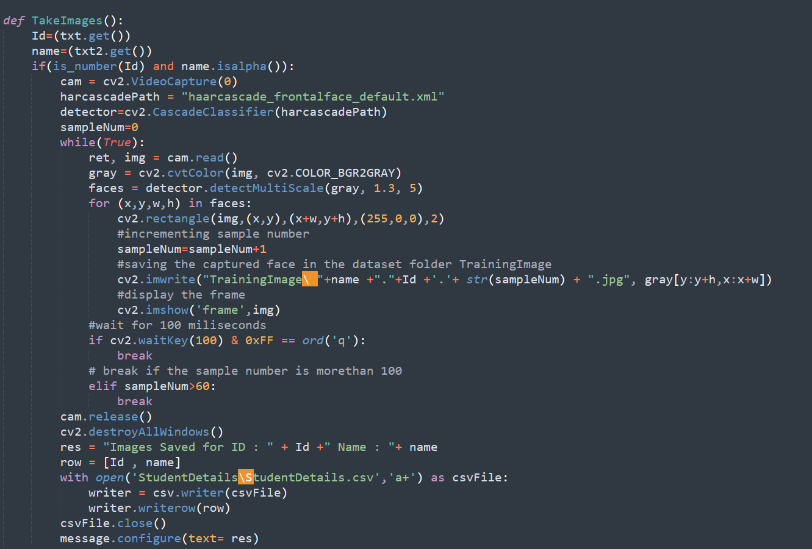

Fig. Take Image Functionality

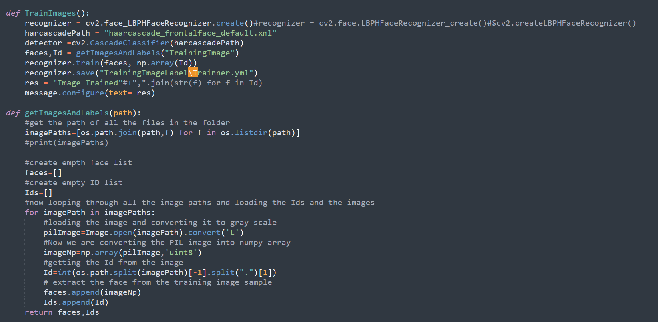

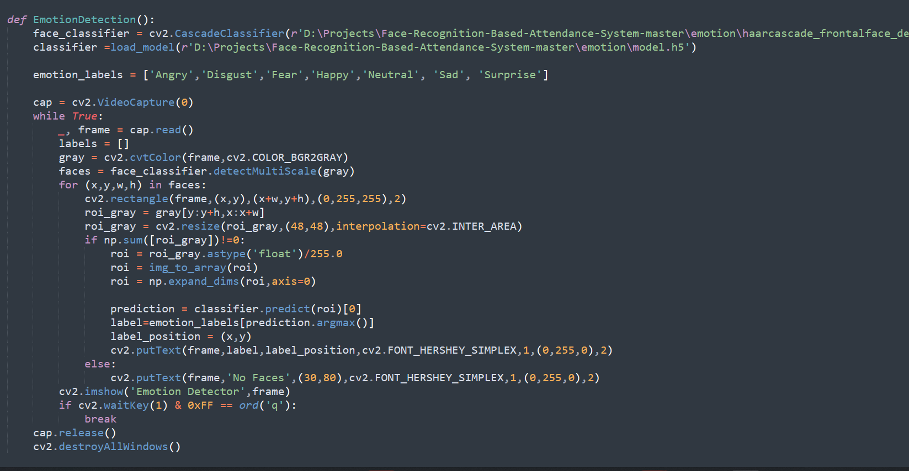

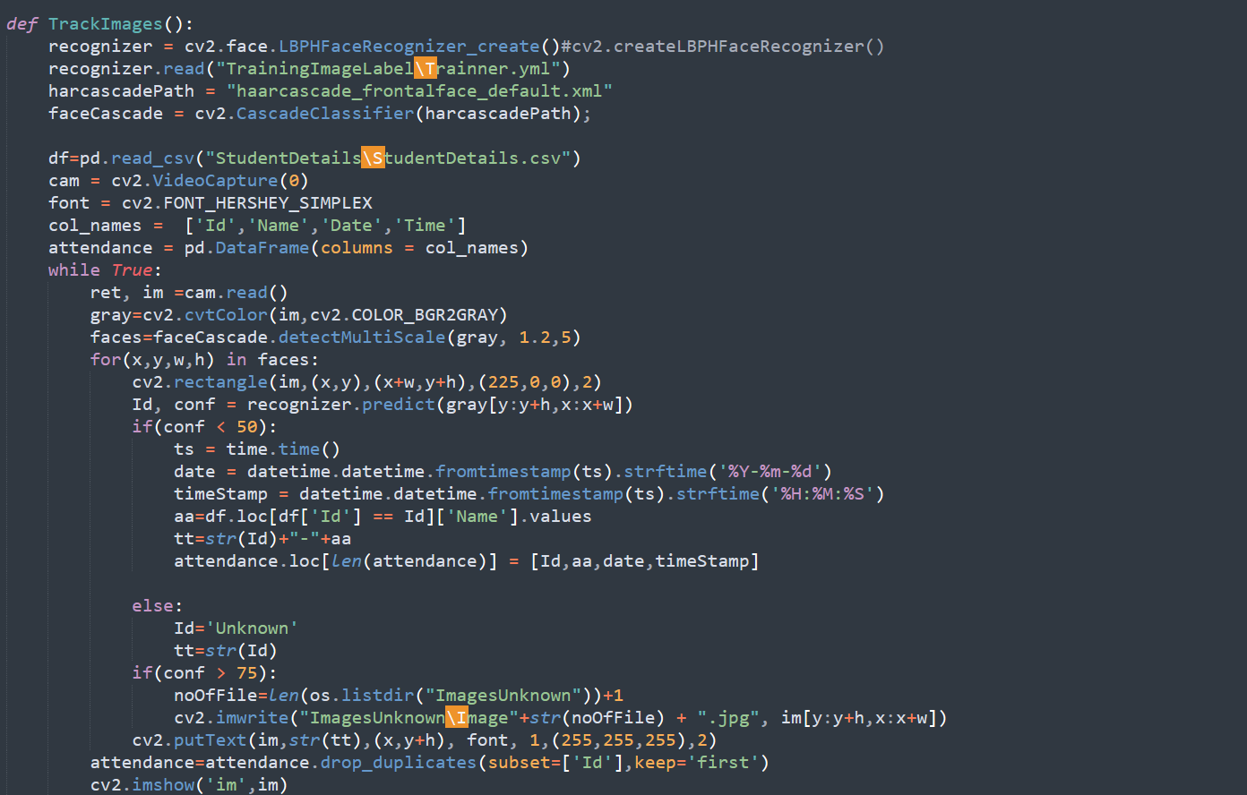

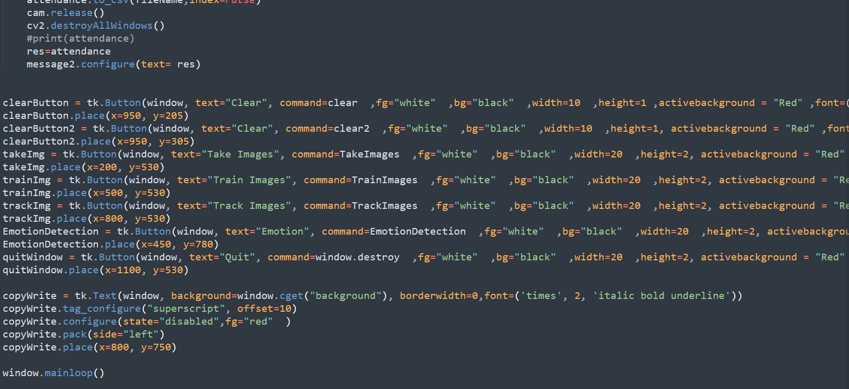

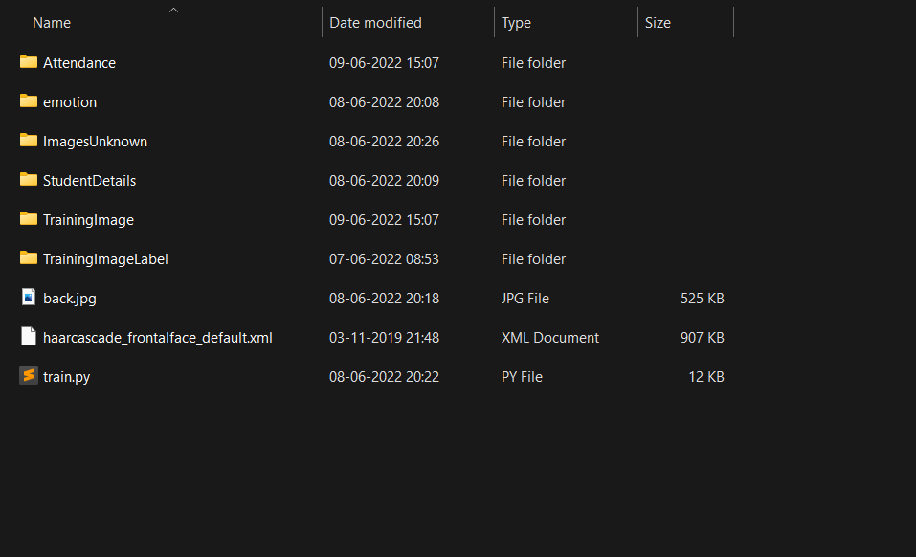

Fig. File Structure

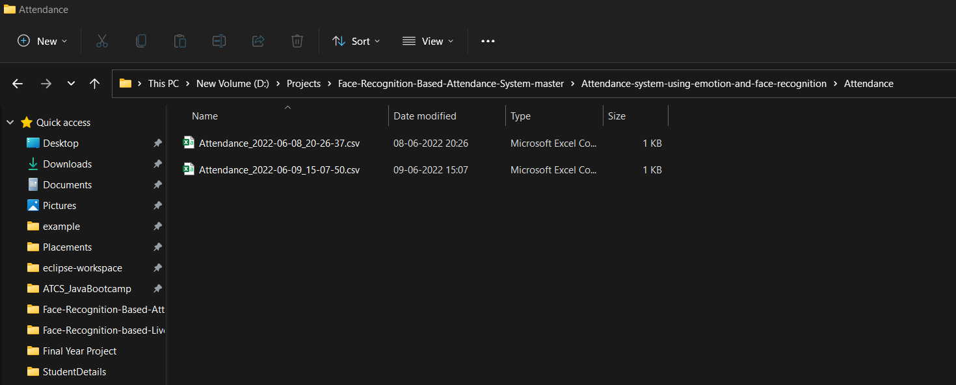

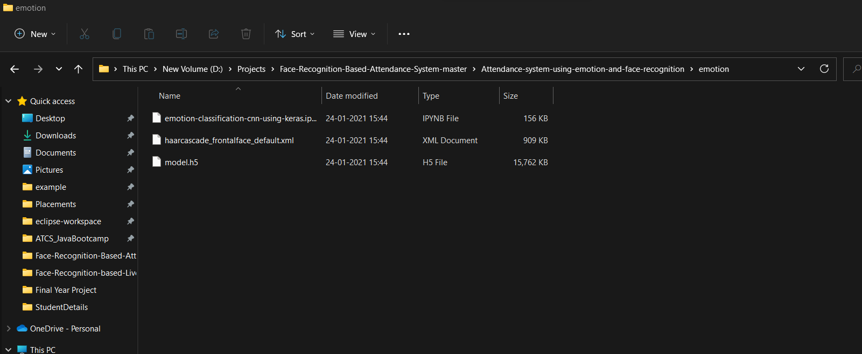

Fig. File Structure of emotion model



Fig. Emotion Detection

**U/I Screen:**

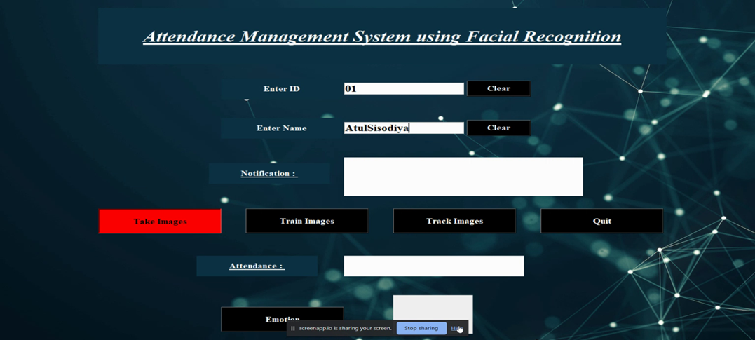

Fig. Main Page

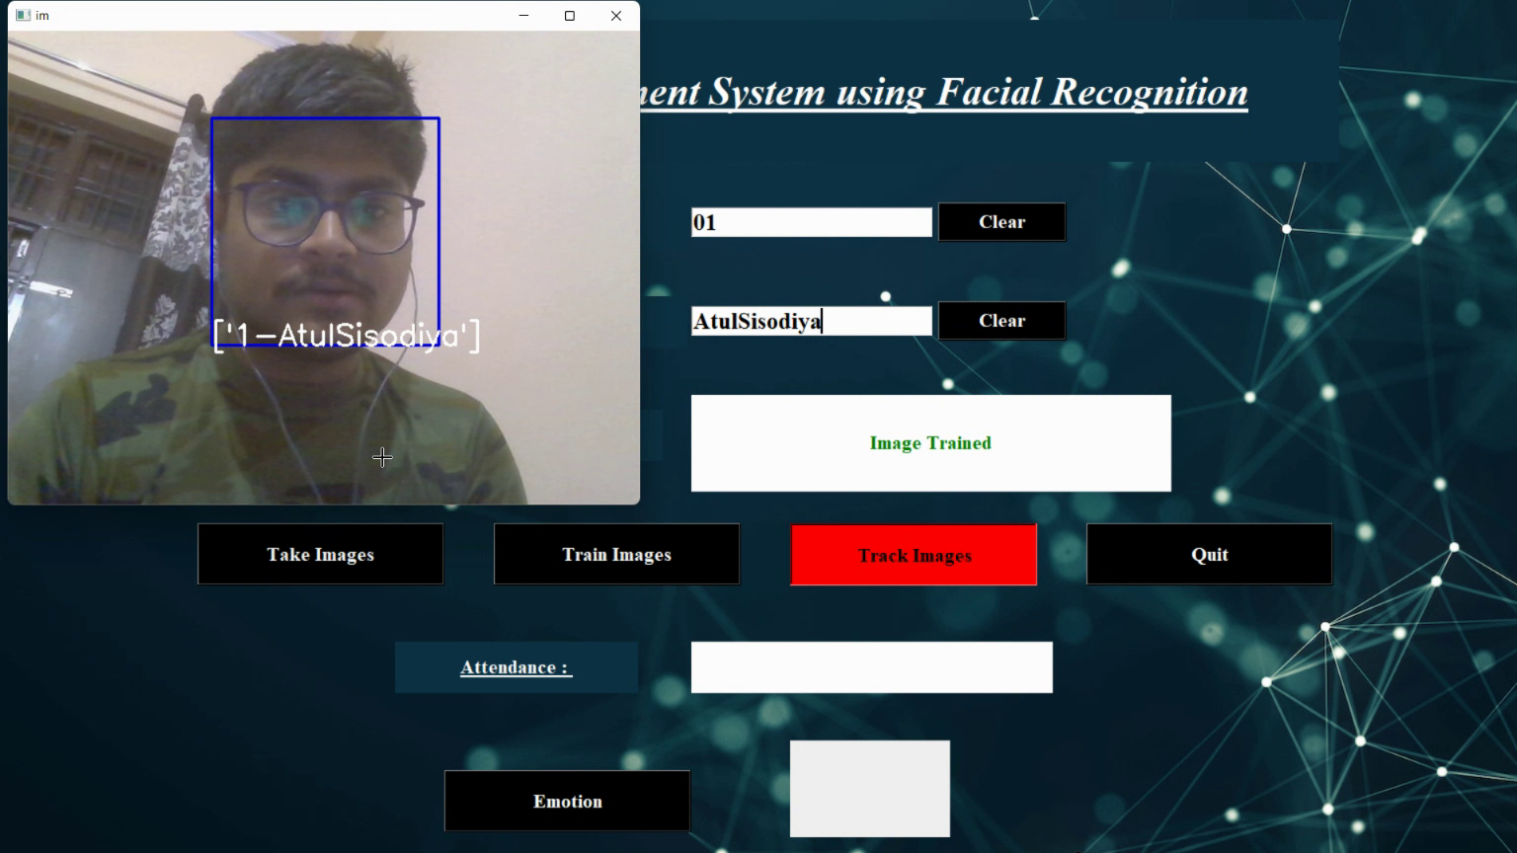

Fig: 13 Track the Image

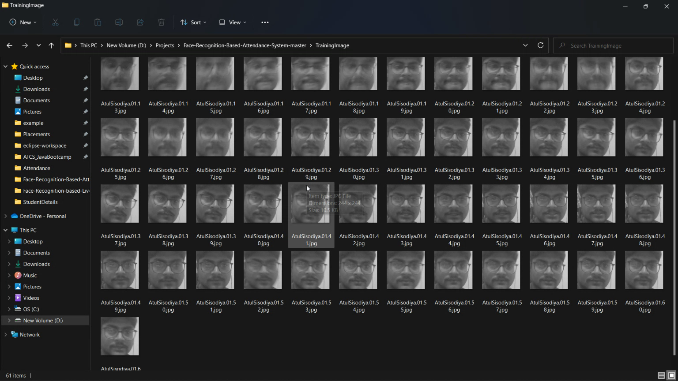

**Fig.** Captured image for a Subject to train Model

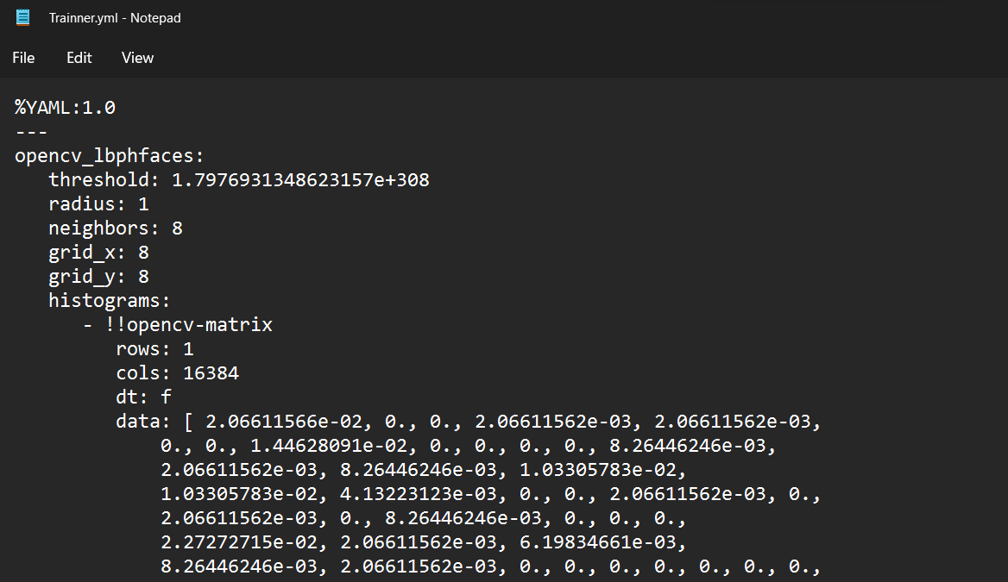

**Fig. Trainer.yml File**

**Resultant Sheet after marking attendance:**

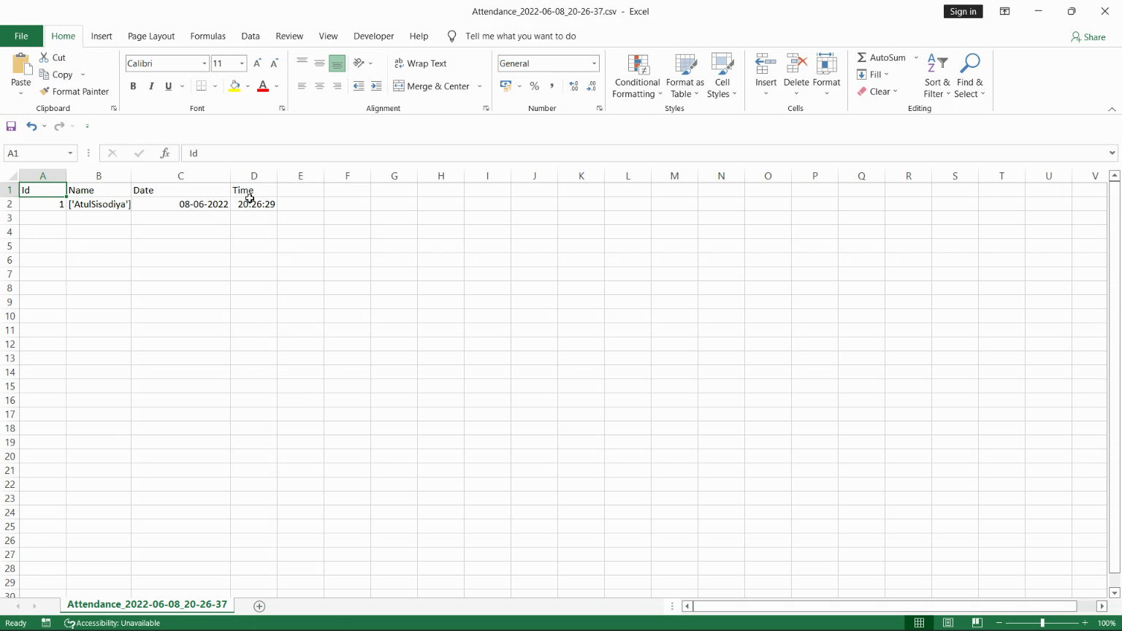

Fig: 14 Excel sheet where data is stored

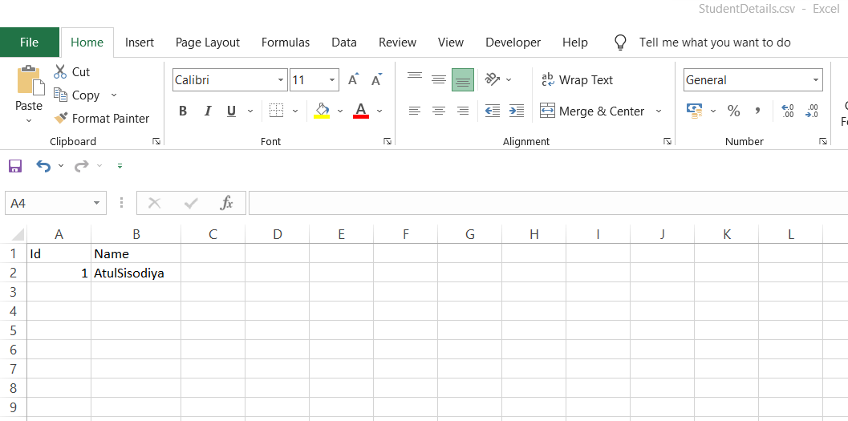

Fig. Student Details csv file

## Limitation:

1)A bit Time consuming.

1. Lack of qualified professional.
2. The model is not able to handle to segregate between a dummy image in some cases.

## Future Scope:

Some destiny works which may be covered to improve the version and to make it greater powerful in practical cases. Our future works consist of applying PCA (primary issue evaluation) in lively studying system to absolutely automate statistics labelling technique with much less assistance from the oracle. The model can be incorporate with programs that may interact with consumer in search of a rating of a specific product. As we used a massive scale dataset, we will practice the version on neighbourhood marketplace web sites to get better accuracy and value. And ultimately we can try and retain this research until we generalize this model to all forms of textual content primarily based reviews and remarks.

# Examples of Sentiment Analysis in Action

**12.1 Social media monitoring**

Emotional statistics are used to track on social media, allowing businesses to understand more clearly what their customers are saying by evaluating specific topics and spotting emergency concerns in real time before they occur. uncontrollable Across all social networks, there are major customer interactions, opportunities, and even competition for all styles and sizes. You may be able to view the consumer's feelings in real time and in the past by tracking those interactions, allowing you to see grieving clients today and respond as swiftly as feasible. body. Many marketing departments have changed the content of the internet in the majority of cases because they believe it is a good thing that promotes brand awareness. Companies, on the other hand, prefer to appear without numbers in order to convey more details.

**12.2 Brand Monitoring**

Not only on social media, but also online, on information sites, blogs, message forums, product ideas, and more, products do not have the finest information. Also, we can observe that the nature and satisfying generality of this statement are more important than the level at which it is expressed. Brand Monitor provides you with a variety of data about your brand's online conversations. Analyse articles, blogs, message boards, and other sources to find out how people are feeling emotionally and objectively about specific census or regions. Automatically enter the urgency of all the symbols mentioned and pass them on to the members of the special group.

**12.3 Voice of Customer (VoC)**

The communication and tracking platform give us with real-time, raw data on consumer sentiment; however, you may include these reviews in test diagrams and customer support encounters. Customers are classified as developers, doers, or scammers using these criteria. The goal is to make the typical consumer happy, and to develop ways to raise all consumers to "promoter" status, where they will, in theory, buy more, live longer, and pass on to new customers.

Emotional assessment can be used to evaluate any form of survey, both quantitative and qualitative, as well as customer service encounters, client opinions, and complaints. Tracking consumer sentiment over time gives you the ability to figure out why NPS criteria or views about your company's character attributes may vary. Real-time statistics allow you to immediately examine variations in VoC and determine whether the consumer enjoys nuances in statistical data and percentages over time.

Learn how we put Facebook's mass ideas to the test and turn the results into usable data.

**12.4 Customer Support**

We're all watching the practice machine because the star buyer is evaluating how to best serve returning clients. Leading companies understand that how they serve is just as important as what they provide, if not more so. Customers want an immediate, straightforward, personal, and hassle-free experience with the company. They will conduct business elsewhere if they can no longer afford it. Did you know that one out of every three customers will leave a lasting impression after just one great show? Examine customer service encounters to make sure your personnel are following the regulations. Increase efficiency so that clients do not expect assistance. Reduce customer churn; after all, retaining consumers is just as difficult as acquiring new ones.

**12.5 Market Research**

Market research and dynamic testing can both benefit from Sentiment testing. An emotional survey can make a difference whether you're researching a new market, forecasting future trends, or seeking for high earnings.

## Conclusion:

This project presents a simple yet eﬃcient approach to calculate the attendance in a class by employing facial recognition techniques. The output of this system can be out-lined as follows:

As is seen in Fig. 6, the system not only detects just one face of a single student, but successfully detects multiple students or faces. As the system works for three faces sat once by law of induction, we can say that it will work for at least more than 15 faces at a single time. The system also successfully recognizes and marks the at-tendance of the detected students. We wish to implement an eﬃcient, time saving and easy to operate system which will in turn beneﬁt both faculty and students.

## References:-

1. Samha, Xu, Xia, Wong & Li “Opinion Annotation in Online Chinese Product Reviews.” In Proceedings of LREC conference, 2008.
2. Nina Isabel Holleschovsky, “Social factor: Impact of Product Reviews”, 5 th IBA Bachelor Thesis Conference, Enschede, The Netherlands 2015
3. Elli, Maria Soledad, and Yi-Fan Wang. "Business analysis using Sentiment Analytics " 2016
4. Xu, Yun, Xinhui Wu, and Qinxia Wang. "Yelp Rating Sentiment Analysis." (2015).
5. Rain, Callen. "Probability based Sentiment Analysis."Swarthmore College (2013).
6. Bhatt, Aashutosh, et al. "Review Classification and Analysis." International Journal of CS & IT 6.6 (2015): 5107-5110.
7. Chen, Weikang, Chihhung Lin, and Yi-Shu Tai."Text-Based Rating Predictions on Amazon Health & Personal Care Product Review.” (2015)
8. Shaikh, Tahura, and DeepaDeshpande. "Sentiment Analysis using Feature Selection Technique.”(2016)
9. Nasr, Essam Shaaban, Mona Mohamed and Ahmed Mostafa Hafez. "Emotional review model using Graphlab" IJSER 2017
10. Text mining for yelp dataset challenge; Mingshan Wang; University of California San Diego, (2017)
11. Elli, Maria Soledad, and Yi-Fan Wang. “Business analysis with sentiment analysis.” 2016
12. Xu, Kaiquan, et al. "Opinion extraction from customer reviews for Intelligent Decision Making & its comparison." Decision support systems 50.4 (2011): 743-754.
13. Miao, Q., Li, Q., & Dai, R. (2009). AMAZING: A sentiment mining and retrieval system. Expert Systems with Applications, 36(3), 7192-7198.
14. He, Ruining, and Julian McAuley. "Ups and downs: Modelling the succession of fashion with single class collaborative filtering."(2016)